OWNERSHIP CERTIFICATE
To Whom It May Concern

Equipment | Diesel Scissor Lift
Brand / Make | Dingli
Asset ID | SG12SL-596
Model Number | GS3390
Serial Number | GS90D-692
Working Height | 12 Meter
Type | 12 Meter - Diesel Scissor Lift
Manufacturing Year | 2017
This is to certify that the following equipment listed below is the sole property of Sudhir Equipment Rental Company:

This certification is issued to confirm the ownership status of the aforementioned equipment. Sudhir Equipment Rental Company holds full legal ownership rights over the listed equipment and retains all associated benefits and responsibilities.
Should there be any queries or requests for verification regarding the ownership of the mentioned equipment, please do not hesitate to contact us at : Info@sudhirrentals.com

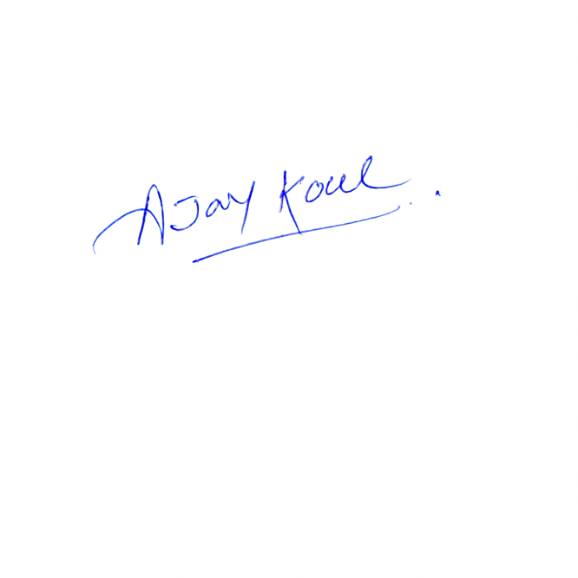
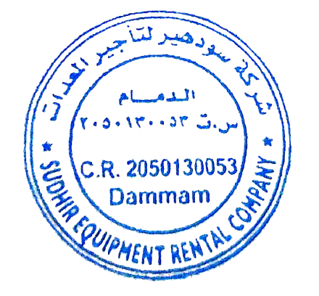
Sincerely,

Ajay Koul
General Manager
Sudhir Equipment Rental Company

